|  |
| --- |
| University of Maryland University College |
| Intro to PHP |
| Creating Simple Web Applications with PHP |
|  |
|  |
|  |

|  |
| --- |
| This lab the summary of building a simple web page that utilizes PHP scripts to create three different tables that provide specific information. The first table provides specific information on geometric shapes, the second table uses existing PHP functions to manipulate text, and the third table used PHP loops to display numbers in patterns. |

Contents

Introduction 1

Overview 1

Lab 4 Submission Requirements 1

Sustains and Improvements 3

Conclusion 3

# Introduction

The purpose of this lab was to create a simple web page that utilized both HTML and PHP to display tables that provided specific information. Three separate tables would be created that each consisted of 2 rows and 2 columns.

# Overview

# 

The first table would provide the area, perimeter, and an image of four shapes. The second table would display a quote in its original form in one table cell, then would use a PHP function to replace a string occurrence with another string in another table cell, find and display the location of all the letter t’s in the string quote in the third table cell, and in the fourth table cell it would convert all letters to upper case. The third and final table would utilize PHP loops to display numbers in predetermined patterns.

# Lab 4 Submission Requirements

Figure 1 below shows the screen shot of the shapes table on the web page. I used object oriented (OO) programming methods and defined a shape super class which contained abstract methods that the subclasses circle, rectangle, triangle, and square inherited. Those methods were then defined in each class. Each shape object was stored in an array and a printable function was used to display the table with relevant shape information.

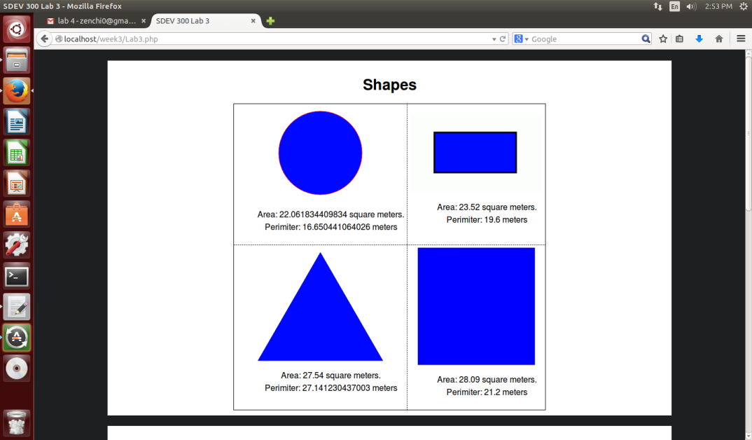

Figure 1 Screenshot of the shapes table

Figure 2 below is the screen shot of the quotes table it uses existing PHP functions to manipulate the text and stores each value into an array and iterates the array to display the information in the table.

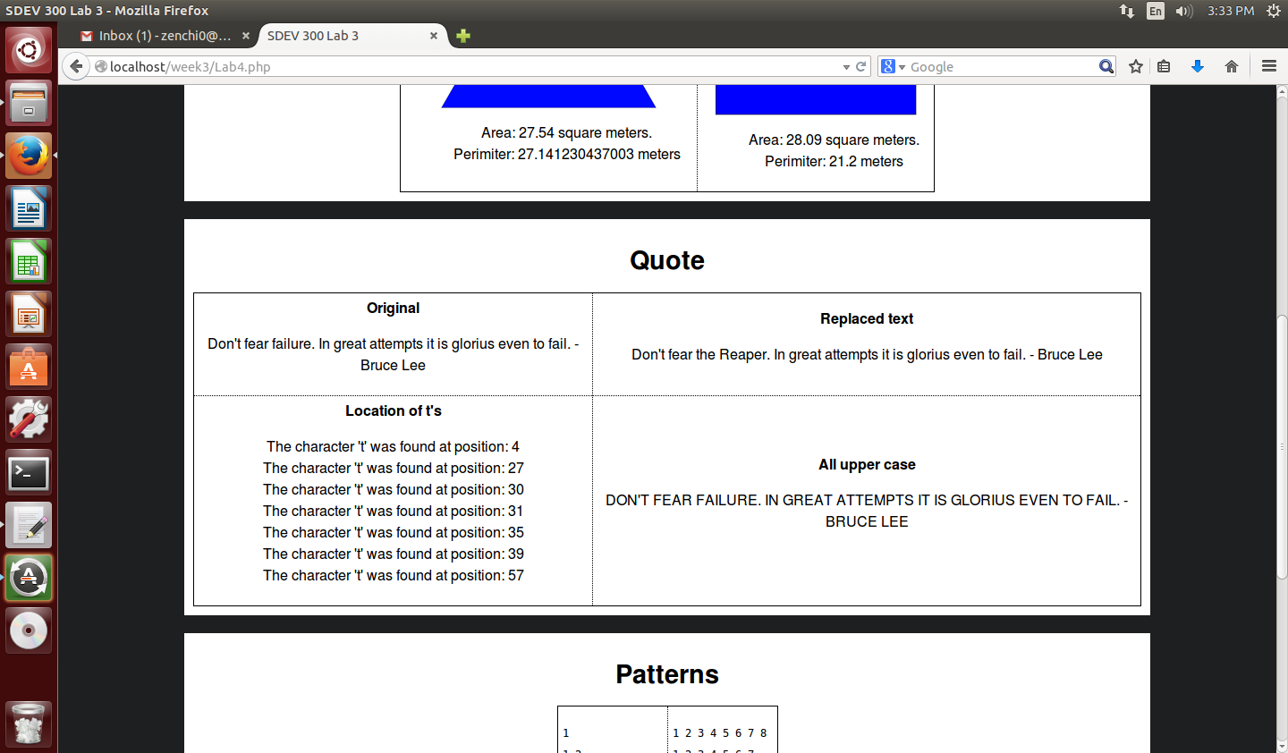

Figure 2 Screehot of the quote table

Figure 3 below is the screen shot of the patterns table. It uses PHP loops the echo numbers in the predetermined patterns and display them in the table.

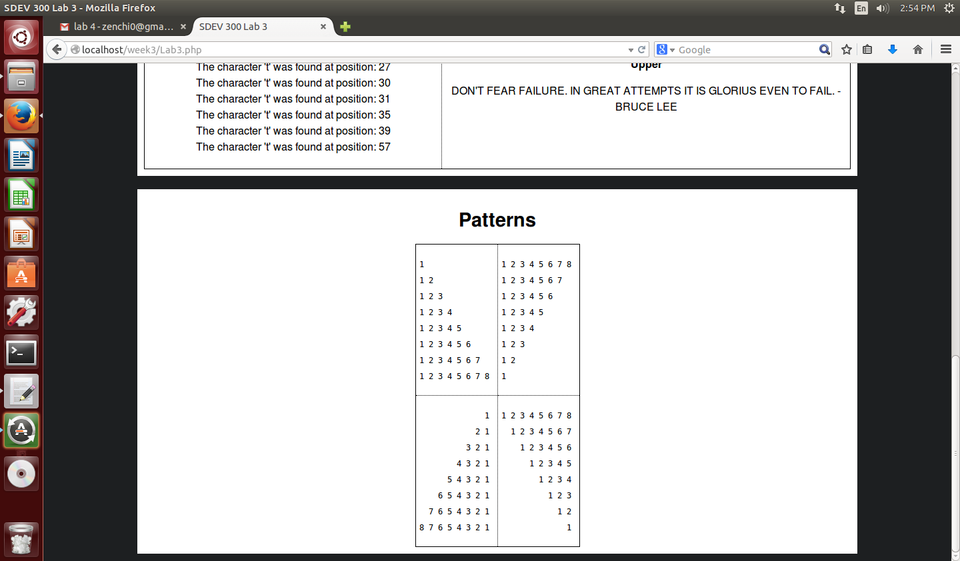

Figure 3 Screenshot of the patterns table

# Sustains and Improvements

The instructions for the lab were very detailed and easy to follow. The screenshots made it very easy to follow along. I would keep those the same. The pre-lab elements were very simple and did help somewhat but the W3schools web site was definitely more useful.

For improvements maybe offering more PHP resources like the tutorialspoint website or encourage students to sign up for free trials of the Google developers console which has a lot of guided walkthroughs of different languages such as PHP and Python.

# Conclusion

This lab on intro to PHP was fairly challenging. It required a decent amount of problem solving skills and research to determine the necessary PHP functions and think through the logical process of how to correctly display the information. I definitely think I have gained a deeper understanding of how to combine HTML and PHP code.